** MINISTRY OF EDUCATION AND TRAINING**

**FPT UNIVERSITY**

Capstone Project Document

The Traffic Sign Recognition and Training

|  |  |
| --- | --- |
| **Group 2** | |
| **Group member** | Mai Văn Tân – Team Leader – SE90061  Bùi Việt Phong – Team Member - SE60747  Hồ Đắc Nghĩa – Team Member - SE60628 |
| **Supervisor** | Mr. Kiều Trọng Khánh |
| **Ext. Supervisor** | N/A |
| **Capstone Project code** | TSRT |

-Ho Chi Minh City, 01/2014-

*This page is intentionally left blank*

***ACKNOWLEDGEMENTS***

# Table of Contents

**Table of Contents 4**

**List of Tables 5**

**List of Figures 7**

Definitions, Acronyms, and Abbreviations 9

Report No.4 Software Desgin Description 10

1. Design Overview 10

2. System Architectural Design 11

3. Component Diagram 12

4. Detailed Description of Components 13

4.1 Class Diagram 13

4.2 Class Diagram Explanation 13

4.3 Sequence Diagram 21

5. Database Design 33

5.1 Logical Diagram 33

5.2 Data Dictionary 34

6. Algorithms 40

6.1 Face Detection 40

6.2 Face Recognition 44

# List of Tables

Table 1: Entity Data Dictionary 32

Table 2: Attribute Data Dictionary 37

# List of Figures

Figure 1: N-tier Architecture 9

Figure 2: Component Diagram 10

Figure 3: Class Diagram 11

Figure 4: Add Image for Singe Student Sequence Diagram 19

Figure 5: Add Image for Many Students Sequence Diagram 19

Figure 6: Delete Student Image Sequence Diagram 20

Figure 7: Create Account Sequence Diagram 20

Figure 8: Configure System Sequence Diagram 21

Figure 9: Face Detection Sequence Diagram 21

Figure 10: Face Recognition Sequence Diagram 22

Figure 11: Auto Free Storage Space Sequence Diagram 22

Figure 12: Auto Active Roll Call Sequence Diagram 23

Figure 13: Add Roll Call Sequence Diagram 23

Figure 14: Edit Roll Call Sequence Diagram 24

Figure 15: Import Student List Sequence Diagram 24

Figure 16: Export Report Sequence Diagram 25

Figure 17: Add Student Sequence Diagram 25

Figure 18: Add Class Sequence Diagram 26

Figure 19:Edit Class Sequence Diagram 26

Figure 20: Add Subject Sequence Diagram 27

Figure 21: Edit Subject Sequence Diagram 27

Figure 22: Take Attendance Auto Sequence Diagram 28

Figure 23: Take Attendance Manual Sequence Diagram 28

Figure 24: View Roll Call Detail Sequence Diagram 29

Figure 25: Report Attendance by Class Sequence Diagram 29

Figure 26: Check Present Rate Sequence Diagram 30

Figure 27: Logical Diagram 31

Figure 28: Example of Haar Future 38

Figure 29: Apply Haar future to sub-window 39

Figure 30: Classifier Cascade 39

Figure 31: Viola-Jones method flowchart 41

Figure 32: Face Recognition Process 42

Figure 33: Face Recognition Algorithm Flowchart 44

# Definitions, Acronyms, and Abbreviations

# Report No.4 Software Design Description

## Design Overview

* This document describes the technical and user interface design of TSRT using mobile device. It includes the architectural design, the detailed design of common functions and business functions and the design of database model.
* The architectural design describes the overall architecture of the system and the architecture of each main component and subsystem.
* The detailed design describes static and dynamic structure for each component and functions. It includes class diagrams, class explanations and sequence diagrams for each Use Cases.
* The database design describes the relationships between entities and details of each entity.
* Document overview:
* Section 2: gives an overall description of the system architecture design.
* Section 3: gives component diagrams that describe the connection and integration of the system.
* Section 4: gives the detail design description include class diagram, class explanation, and sequence diagram to details the application functions.
* Section 5: describe an ERD with logical diagram.

## System Architectural Design

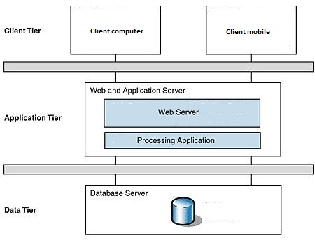

Figure 28: N-tier Architecture

<http://www.cardisoft.gr/frontend/article.php?aid=87&cid=96>

* **Client Tier**: The client tier interacts with the users for the solution. Since the application conforms to a three layered services application it hosts the presentation layer components.
* **Application Tier**: The servers used in the application tier are responsible for host­ing all the application's business components and, in the case of Web applications, the Web servers as well.
* **Data Tier**: The servers in the data tier host the databases that the application requires; it is within this tier that the data layer is hosted.

## Component Diagram

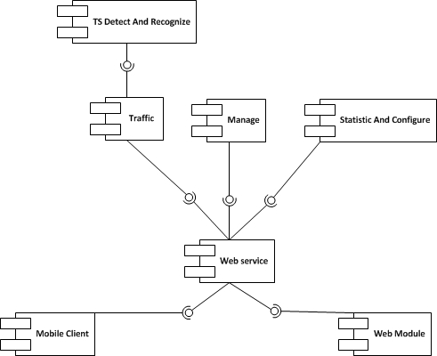

Figure 29: Component Diagram

**Data Dictionary**

|  |  |
| --- | --- |
| **Name** | **Description** |
| TS Detect And Recognize | Provide functions to detect and recognize traffic sign |
| Traffic | Provide functions about traffic sign: manage, search |
| Manage | Provide functions to manage account, favorite |
| Statistic And Configure | Provide functions to statistic and configure server |
| Web service | Provide service interface using http protocol |
| Mobile client | Provide functions in mobile |
| Web Module | Provide functions in web |

## Detailed Description of Components

### Class Diagram

–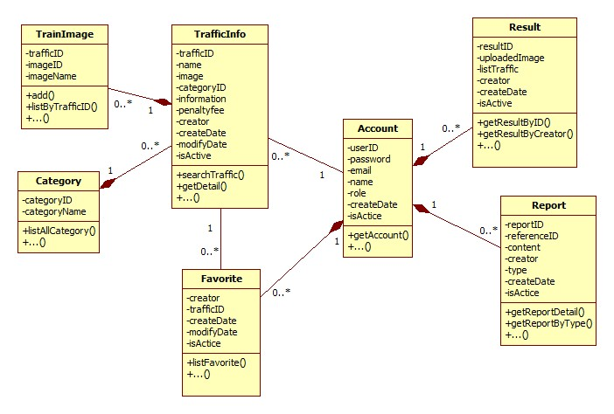

Figure 30: Class Diagram

### Class Diagram Explanation

#### TrafficInfo

Attribute

|  |  |  |  |
| --- | --- | --- | --- |
| **Attribute** | **Type** | **Visibility** | **Description** |
| trafficID | String | Private | Traffic sign no |
| name | String | Private | Name of traffic sign |
| image | String | Private | Traffic sign image link |
| categoryID | Int | Private | Category ID of traffic sign |
| information | String | Private | Content of traffic sign |
| penaltyfee | String | Private | Penalty fee of traffic sign |
| creator | String | Private | Creator of traffic sign |
| createDate | Date | Private | Create date |
| modifyDate | Date | Private | Modify date |
| isActive | Boolean | Private | Status of traffic sign |

Method

|  |  |  |  |
| --- | --- | --- | --- |
| **Method** | **Return Type** | **Visibility** | **Description** |
| searchTraffic() | ArrayList<TrafficInfo> | Public | Search traffic by input parameter: name, cateID, limit |
| getDetail() | TrafficInfo | Public | Get traffic sign detail |

#### Account

Attribute

|  |  |  |  |
| --- | --- | --- | --- |
| **Attribute** | **Type** | **Visibility** | **Description** |
| userID | String | Private | UserID |
| password | String | Private | User’s password in MD5 form |
| email | String | Private | User’s email |
| name | String | Private | User’s name |
| role | String | Private | Role in system |
| createDate | Date | Private | Create date |
| isActive | Boolean | Private | Status |

Method

|  |  |  |  |
| --- | --- | --- | --- |
| **Method** | **Return Type** | **Visibility** | **Description** |
| getAccount() | Account | Public | Get user information |

#### Category

Attribute

|  |  |  |  |
| --- | --- | --- | --- |
| **Attribute** | **Type** | **Visibility** | **Description** |
| categoryID | Int | Private | ID of category |
| categoryName | String | Private | Name of category |

Method

|  |  |  |  |
| --- | --- | --- | --- |
| **Method** | **Return Type** | **Visibility** | **Description** |
| listAllCategory() | ArrayList<Category> | Public | Get list all category |

#### TrainImage

Attribute

|  |  |  |  |
| --- | --- | --- | --- |
| **Attribute** | **Type** | **Visibility** | **Description** |
| trafficID | String | Private | TrafficID of Image |
| imageID | String | Private | ID of image |
| imageName | String | Private | Name of image |

Method

|  |  |  |  |
| --- | --- | --- | --- |
| **Method** | **Return Type** | **Visibility** | **Description** |
| add() | Boolean | Public | Add a train image |
| listByTrafficID() | ArrayList<TrainImage> | Public | List all train image of a traffic sign |

#### Favorite

Attribute

|  |  |  |  |
| --- | --- | --- | --- |
| **Attribute** | **Type** | **Visibility** | **Description** |
| creator | String | Private | Creator of favorite |
| trafficID | String | Private | Traffic ID of favorite |
| createDate | Date | Private | Create date |
| modifyDate | Date | Private | Modify date |
| isActive | Boolean | Private | Status |

Method

|  |  |  |  |
| --- | --- | --- | --- |
| **Method** | **Return Type** | **Visibility** | **Description** |
| listFavorite() | ArrayList<Favorite> | Public | List all favorite of an user |

#### Result

Attribute

|  |  |  |  |
| --- | --- | --- | --- |
| **Attribute** | **Type** | **Visibility** | **Description** |
| resultID | Int | Private | Unique ID for result |
| uploadedImage | String | Private | Image link of result |
| listTraffic | String | Private | List result contain trafficID and their location in image |
| creator | String | Private | Creator of result |
| createDate | Date | Private | Create date |
| isActive | Boolean | Private | Status of result |

Method

|  |  |  |  |
| --- | --- | --- | --- |
| **Method** | **Return Type** | **Visibility** | **Description** |
| getResultByID() | Result | Public | Get result detail by ID |
| getResultByCreator() | ArrayList<Result> | Public | Get all result of an user |

#### Report

Attribute

|  |  |  |  |
| --- | --- | --- | --- |
| **Attribute** | **Type** | **Visibility** | **Description** |
| reportID | Int | Private | Unique id for report |
| referenceID | String | Private | Reference Id of report, this ID reference to TrafficInfo or Result depend on type of report |
| content | String | Private | Content of report |
| creator | String | Private | Creator of report |
| type | Int | Private | Type of report. 1 for wrong recognize, 2 for wrong traffic information |
| createDate | Date | Private | Create date |
| isActive | Boolean | Private | Status |

Method

|  |  |  |  |
| --- | --- | --- | --- |
| **Method** | **Return Type** | **Visibility** | **Description** |
| getReportDetail() | Report | Public | Get detail of report |
| getReportByType | ArrayList<Report> | Public | Get all report by type |

### Sequence Diagram

#### Add Traffic Sign

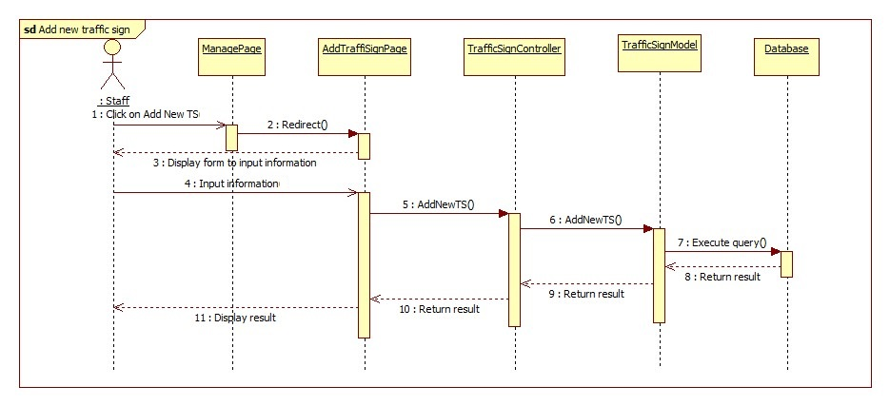

Figure 31: Add Traffic Sign Sequence Diagram

#### Add Train Image

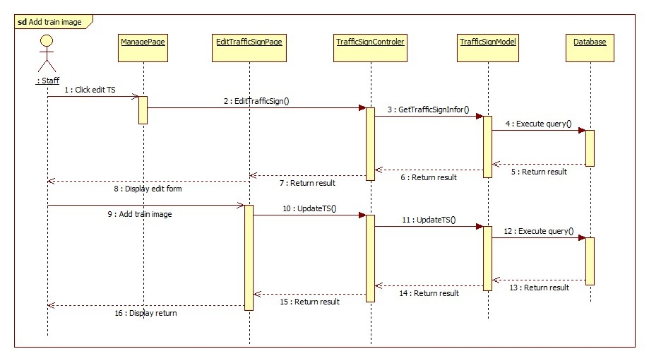

Figure 32: Add Train Image Sequence Diagram

#### Import Data From File

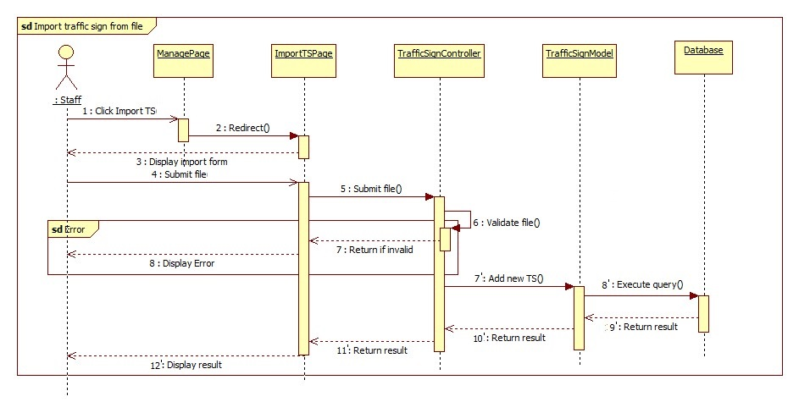

Figure 33: Import Data From File Sequence Diagram

#### Search Traffic Sign Auto

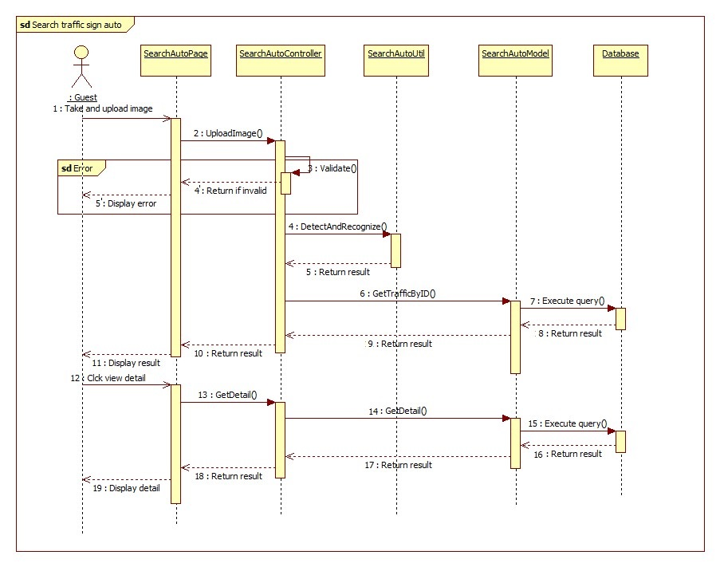

Figure 34: Search Traffic Sign Auto Sequence Diagram

#### Search Traffic Sign Manual

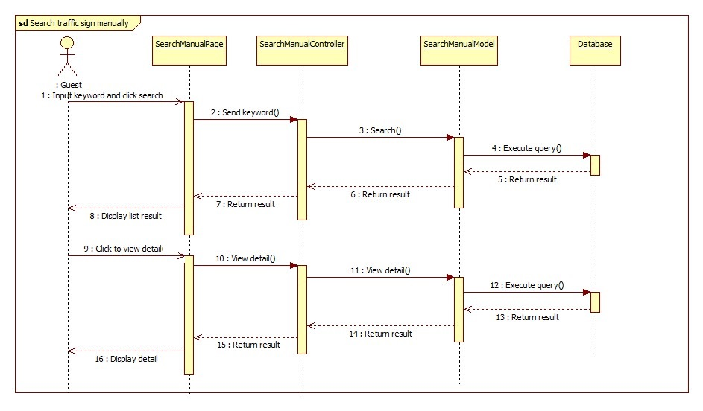

Figure 35: Search Traffic Sign Manual Sequence Diagram

## User Interface Design

### User Interface Design

#### User Home Page

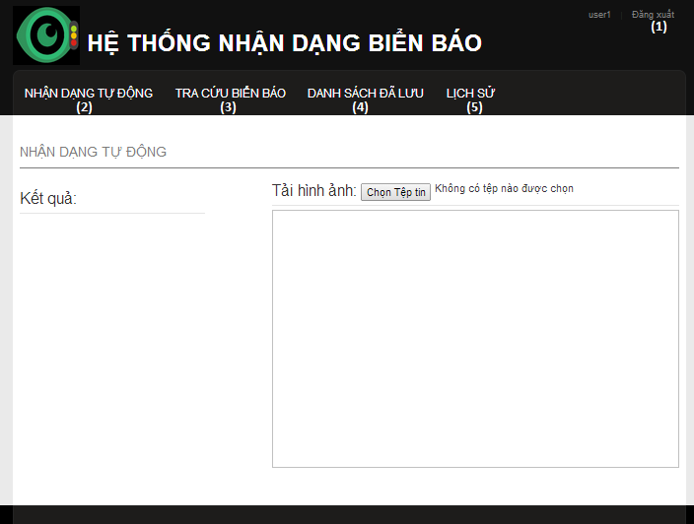

Figure 36: User Home Page

**Button/ Hyperlink**

|  |  |  |  |  |
| --- | --- | --- | --- | --- |
| **No** | **Function** | **Description** | **Validation** | **Outcome** |
| 1 | Logout | Click to logout | No | Delete session and return to Home page |
| 2 | Search auto | Click to go to search auto page | No | Search auto Page |
| 3 | Search manual | Click to go to search manual page | No | Search manual page |
| 4 | Favorite | Click to View favorite list | No | Get the favorite list from service and return to Favorite page |
| 5 | History | Click to view history list | No | Get the history list from service and return to history page |

#### User – Search auto

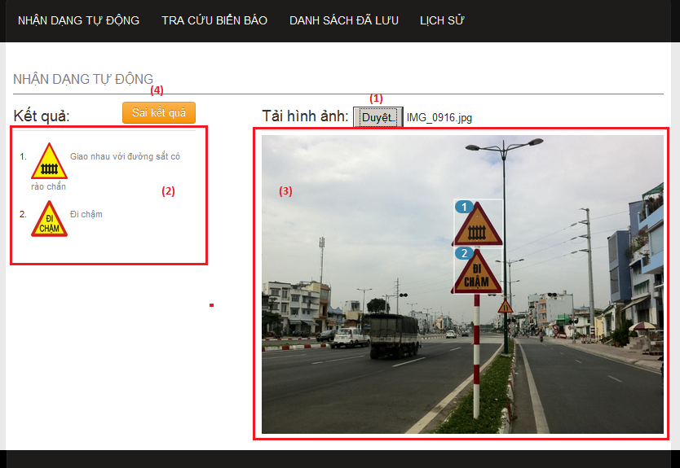

Figure 37: User – Search auto

**Fields**

|  |  |  |  |  |  |  |  |
| --- | --- | --- | --- | --- | --- | --- | --- |
| **No** | **Field Name** | **Description** | **Read only** | **Mand-atory** | **Control Type** | **Data Type** | **Length** |
| 3 | Image preview | Show image was upload by user. | Y | Y | Image tag | N/A | N/A |

**Button/ Hyperlink**

|  |  |  |  |  |
| --- | --- | --- | --- | --- |
| **No** | **Function** | **Description** | **Validation** | **Outcome** |
| 1 | Select image for upload | Click to select an image to upload for search traffic signs | No | Upload image to service and show the result |
| 2 | List result | Show list result matching with number in the image. Click one item to view traffic sign detail | No | Show popup to view traffic sign details |
| 4 | Send report | Click to show popup to send report | No | Show popup to send report |

#### User – Search manual

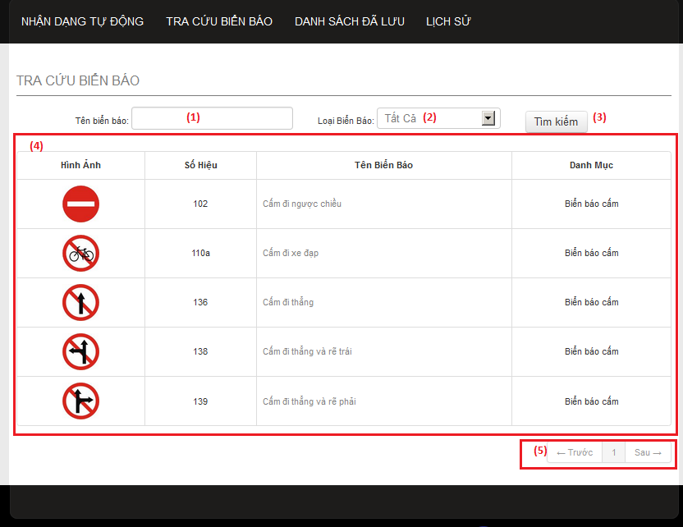

Figure 38: User – Search manual

**Fields**

|  |  |  |  |  |  |  |  |
| --- | --- | --- | --- | --- | --- | --- | --- |
| **No** | **Field Name** | **Description** | **Read only** | **Mand-atory** | **Control Type** | **Data Type** | **Length** |
| 1 | Search key | Enter traffic name to search. | N | N | Input tag | Strin-g | N/A |
| 2 | Category | Select one category type to search | N | Y | Select tag | N/A | N/A |
| 4 | List result | Display result after search manual | Y | Y | Table | N/A | N/A |

**Button/ Hyperlink**

|  |  |  |  |  |
| --- | --- | --- | --- | --- |
| **No** | **Function** | **Description** | **Validation** | **Outcome** |
| 3 | Search manual | Click to search traffic sign by traffic sign’s name and category. | No | Show list result to the table below. |
| 4 | Paging | Select number or “Trước”, “Sau” to view others records in the table. | No | Change page in the table |

**Table List Result includes**

|  |  |  |  |  |  |
| --- | --- | --- | --- | --- | --- |
| **Field Name** | **Description** | **Read only** | **Control Type** | **Data Type** | **Length** |
| “Hình ảnh” | Traffic sign’s image. Click to view traffic sign detail | Y | Image | N/A | N/A |
| “Số hiệu” | Traffic sign’s ID number | Y | Label | String | N/A |
| “Tên biển báo” | Traffic sign’s name. Click to view traffic sign detail | Y | Label | String | N/A |
| “Danh mục” | Traffic sign’s category | Y | Label | String | N/A |

#### User – Favorite list

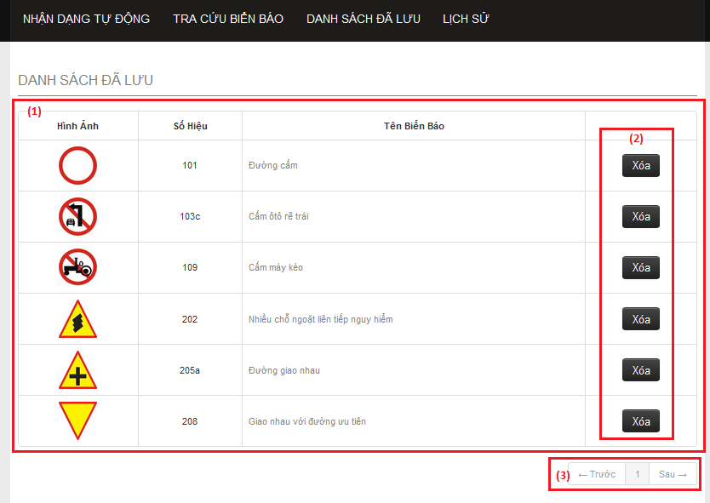

Figure 39: User – Favorite list

**Fields**

|  |  |  |  |  |  |  |  |
| --- | --- | --- | --- | --- | --- | --- | --- |
| **No** | **Field Name** | **Description** | **Read only** | **Mandatory** | **Control Type** | **Data Type** | **Length** |
| 1 | Favorite List Table | The list of traffic signs in the favorite. | N | Y | Table | N/A | N/A |

**Button/ Hyperlink**

|  |  |  |  |  |
| --- | --- | --- | --- | --- |
| **No** | **Function** | **Description** | **Validation** | **Outcome** |
| 2 | Delete favorite | Click to delete traffic sign from favorite list. | No | Send delete request to service and delete a row in table. |
| 3 | Paging | Select number or “Trước”, “Sau” to view others records in the table. | No | Change page in the table |

**Table Favorite list includes**

|  |  |  |  |  |  |
| --- | --- | --- | --- | --- | --- |
| **Field Name** | **Description** | **Read only** | **Control Type** | **Data Type** | **Length** |
| “Hình ảnh” | Traffic sign’s image. Click to view traffic sign detail | Y | Image | N/A | N/A |
| “Số hiệu” | Traffic sign’s ID number | Y | Label | String | N/A |
| “Tên biển báo” | Traffic sign’s name. Click to view traffic sign detail | Y | Label | String | N/A |
| Action | Button to delete traffic sign from favorite list. | Y | Button | N/A | N/A |

#### User – History list

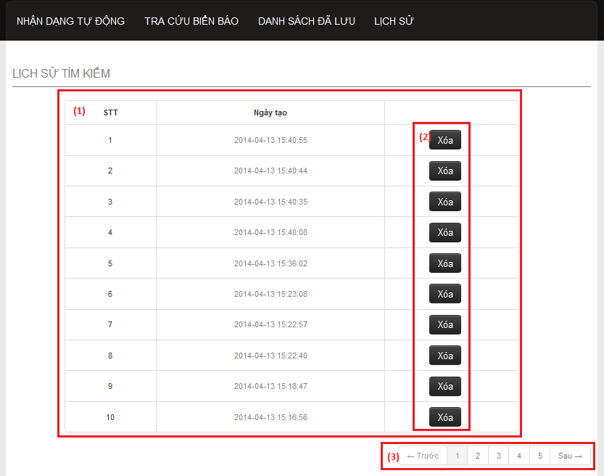

Figure 40: User – History list

**Fields**

|  |  |  |  |  |  |  |  |
| --- | --- | --- | --- | --- | --- | --- | --- |
| **No** | **Field Name** | **Description** | **Read only** | **Mandatory** | **Control Type** | **Data Type** | **Length** |
| 1 | History list | The list history. | N | Y | Table | N/A | N/A |

**Button/ Hyperlink**

|  |  |  |  |  |
| --- | --- | --- | --- | --- |
| **No** | **Function** | **Description** | **Validation** | **Outcome** |
| 2 | Delete history | Click to delete one history record in the table. | No | Send delete request to service and delete a row in table. |
| 3 | Paging | Select number or “Trước”, “Sau” to view others records in the table. | No | Change page in the table |

**Table History list includes**

|  |  |  |  |  |  |
| --- | --- | --- | --- | --- | --- |
| **Field Name** | **Description** | **Read only** | **Control Type** | **Data Type** | **Length** |
| “STT” | Display row’s position in table. | Y | Label | String | N/A |
| “Ngày tạo” | Display history ‘s create time | Y | Label | String | N/A |
| Action | Button to delete history. | Y | Button | N/A | N/A |

#### User – Traffic sign detail

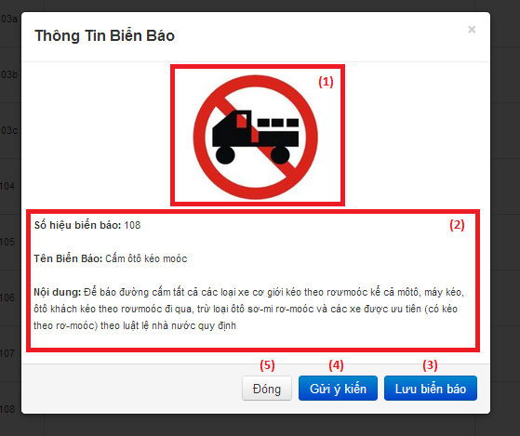

Figure 41: User – Traffic sign detail

**Fields**

|  |  |  |  |  |  |  |  |
| --- | --- | --- | --- | --- | --- | --- | --- |
| **No** | **Field Name** | **Description** | **Read only** | **Mandatory** | **Control Type** | **Data Type** | **Length** |
| 1 | Traffic sign’s image | Display traffic sign’s image. | Y | Y | Image tag | N/A | N/A |
| 2 | Traffic sign information | Display traffic sign detail information | Y | Y | Label | String | N/A |

**Button/ Hyperlink**

|  |  |  |  |  |
| --- | --- | --- | --- | --- |
| **No** | **Function** | **Description** | **Validation** | **Outcome** |
| 3 | Add favorite | Click to add traffic sign to favorite list. | No | Send add favorite request to service and change button to “Xóa biển báo”. |
| 4 | Send report | Click to show popup for send report. | No | Show popup send report |
| 5 | Close popup | Click to close popup | No | Popup close. |

**Table History list includes**

|  |  |  |  |  |  |
| --- | --- | --- | --- | --- | --- |
| **Field Name** | **Description** | **Read only** | **Control Type** | **Data Type** | **Length** |
| “STT” | Display row’s position in table. | Y | Label | String | N/A |
| “Ngày tạo” | Display history ‘s create time | Y | Label | String | N/A |
| Action | Button to delete history. | Y | Button | N/A | N/A |

#### User – Send report

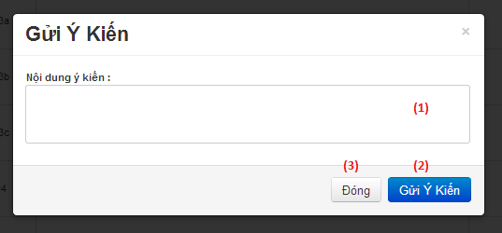

Figure 42: User – Send report

**Fields**

|  |  |  |  |  |  |  |  |
| --- | --- | --- | --- | --- | --- | --- | --- |
| **No** | **Field Name** | **Description** | **Read only** | **Mandatory** | **Control Type** | **Data Type** | **Length** |
| 1 | Report content | Enter report content to this field. | N | Y | Textbox | String | N/A |

**Button/ Hyperlink**

|  |  |  |  |  |
| --- | --- | --- | --- | --- |
| **No** | **Function** | **Description** | **Validation** | **Outcome** |
| 2 | Submit report | Click to send report. | No | Send report to server and close popup. |
| 3 | Close popup | Click to close popup | No | Popup close. |

### Admin Interface Design

#### Admin - Home Page

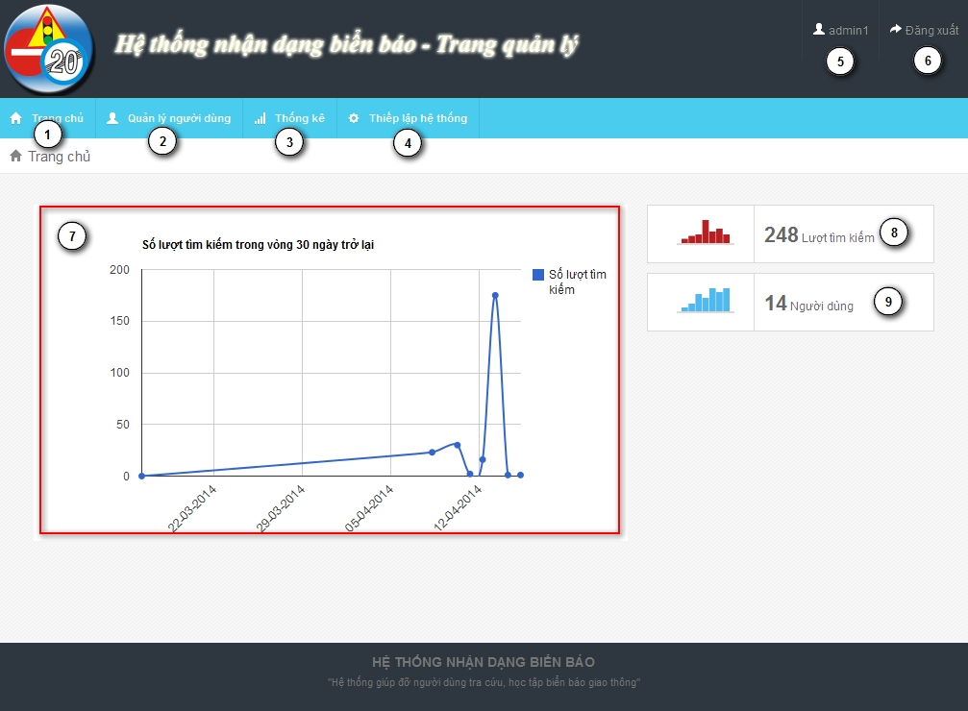

Figure 43: Admin - Home Page

**Fields**

|  |  |  |  |  |  |  |  |
| --- | --- | --- | --- | --- | --- | --- | --- |
| **No** | **Field Name** | **Description** | **Read only** | **Mand-atory** | **Control Type** | **Data Type** | **Length** |
| 5 | Username | username of user | Y | Y | Label | String | N/A |
| 7 | Statistic | Statistic of last 30 days search times | Y | Y | N/A | N/A | N/A |
| 8 | Total search times | Total search auto times | Y | Y | N/A | N/A | N/A |
| 9 | Total user | Total user registered in system | Y | Y | N/A | N/A | N/A |

**Button/ Hyperlink**

|  |  |  |  |  |
| --- | --- | --- | --- | --- |
| **No** | **Function** | **Description** | **Validation** | **Outcome** |
| 1 | Home page | Click to go to home page | No | Home page |
| 2 | Account manager page | Click to go to account manage page | No | Account manage page |
| 3 | Statistic page | Click to go to statistic page | No | Statistic page |
| 4 | Configure page | Click to go to configure page | No | Configure page |
| 6 | Log out button | Click to log out | No | Login page |

#### Admin - Account Manager Page

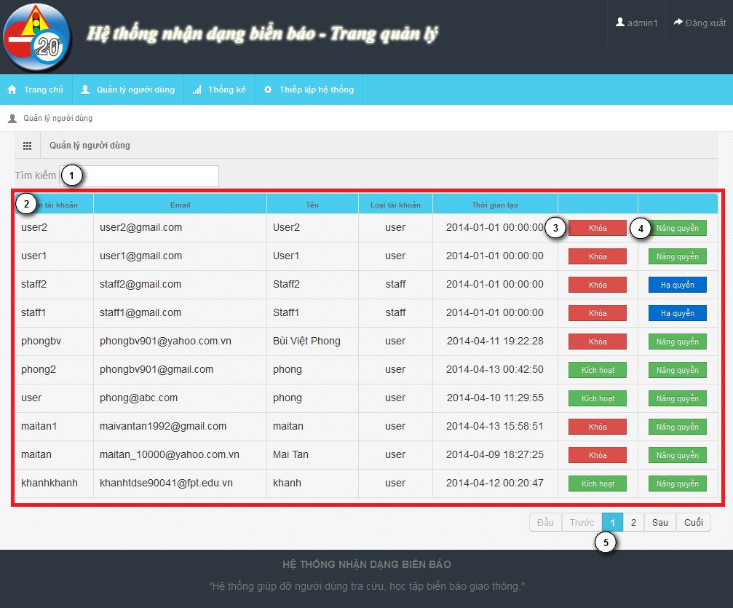

Figure 44: Admin - Account Manager Page

**Fields**

|  |  |  |  |  |  |  |  |
| --- | --- | --- | --- | --- | --- | --- | --- |
| **No** | **Field Name** | **Description** | **Read only** | **Mand-atory** | **Control Type** | **Data Type** | **Length** |
| 1 | Search field | Search textbox for the table | N | Y | Textbox | String | N/A |
| 2 | Account list | List account in system | Y | Y | Table | N/A | N/A |

**Button/ Hyperlink**

|  |  |  |  |  |
| --- | --- | --- | --- | --- |
| **No** | **Function** | **Description** | **Validation** | **Outcome** |
| 3 | Active/Deactivate | Active/deactivate account | No | Change text of button |
| 4 | Set/Unset staff role | Use to set or unset staff role | No | Change text of button |
| 5 | Paging | Paging area of the student table | No | Change page of the table |

**Table Account List includes**

|  |  |  |  |  |  |
| --- | --- | --- | --- | --- | --- |
| **Field Name** | **Description** | **Read only** | **Control Type** | **Data Type** | **Length** |
| UserID | UserID of account | Y | Label | String | N/A |
| Email | Email of account | Y | Label | String | N/A |
| Name | Name of account | Y | Label | String | N/A |
| Role | Role of account | Y | Label | String | N/A |
| Create date | Create date of account | Y | Label | String | N/A |
| Function | Active/Deactivate account | N | Button | N/A | N/A |
| Function | Set/Unset staff role | N | Button | N/A | N/A |

#### Admin - Statistic Page

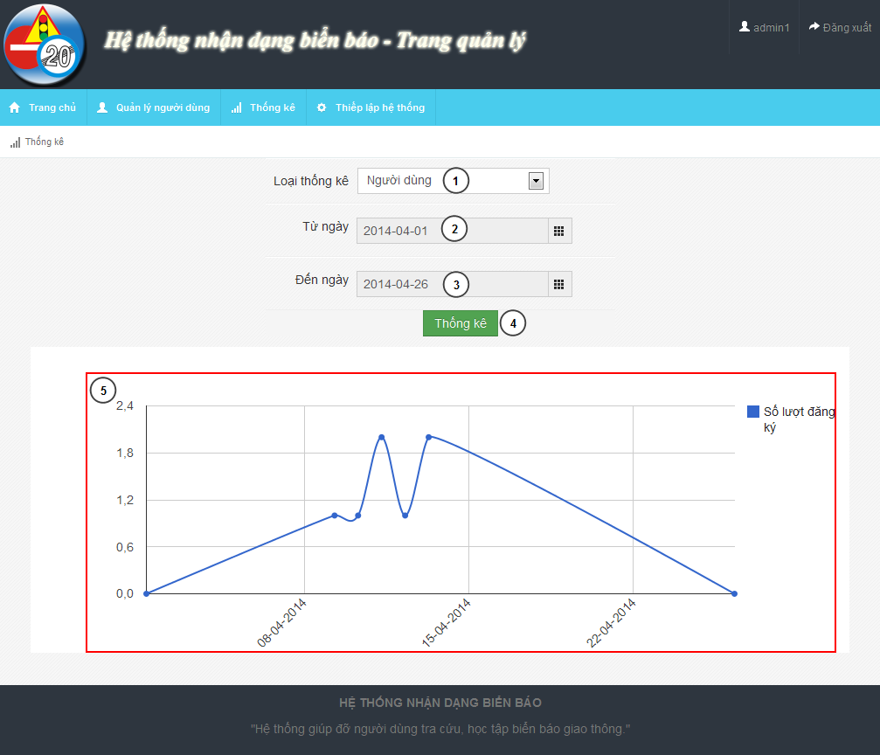

Figure 45: Admin - Statistic Page

**Fields**

|  |  |  |  |  |  |  |  |
| --- | --- | --- | --- | --- | --- | --- | --- |
| **No** | **Field Name** | **Description** | **Read only** | **Mand-atory** | **Control Type** | **Data Type** | **Length** |
| 1 | Statistic type | Type of statistic | N | Y | Dropdown-list | String | N/A |
| 2 | From date | From date to begin statistic | N | Y | Date picker | N/A | N/A |
| 3 | To date | To date to end of statistic | N | Y | Date picker | N/A | N/A |
| 5 | Chart field | Line chart description of the statistic information | N/A | Y | N/A | N/A | N/A |

**Button/ Hyperlink**

|  |  |  |  |  |
| --- | --- | --- | --- | --- |
| **No** | **Function** | **Description** | **Validation** | **Outcome** |
| 4 | Show statistic | Shot statistic information in chart field | From date and to date not empty, from date not after to date | Chart field |

#### Admin - Configure Page

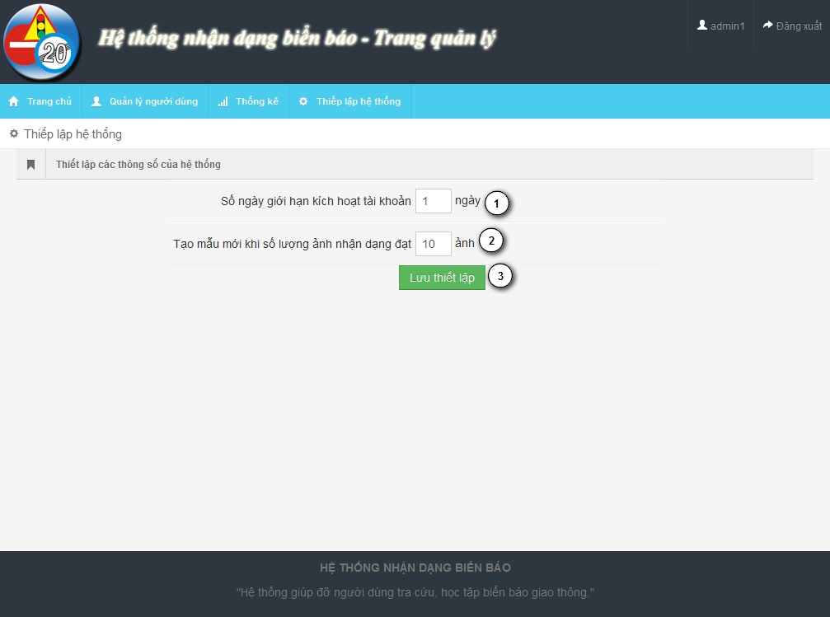

Figure 46: Admin - Configure Page

**Fields**

|  |  |  |  |  |  |  |  |
| --- | --- | --- | --- | --- | --- | --- | --- |
| **No** | **Field Name** | **Description** | **Read only** | **Mand-atory** | **Control Type** | **Data Type** | **Length** |
| 1 | Active day | The limit active day after register | N | Y | Textbox | Integer | [0..] |
| 2 | Retrain count | The train count limit after retrain model data | N |  | Textbox | Integer | [0..] |

**Button/ Hyperlink**

|  |  |  |  |  |
| --- | --- | --- | --- | --- |
| **No** | **Function** | **Description** | **Validation** | **Outcome** |
| 3 | Save configure | Save configure information | No | N/A |

### Staff Interface Design

#### Staff – Home Page

The same with Admin – Home page in 5.2.1

#### Staff – Traffic Sign Manager Page

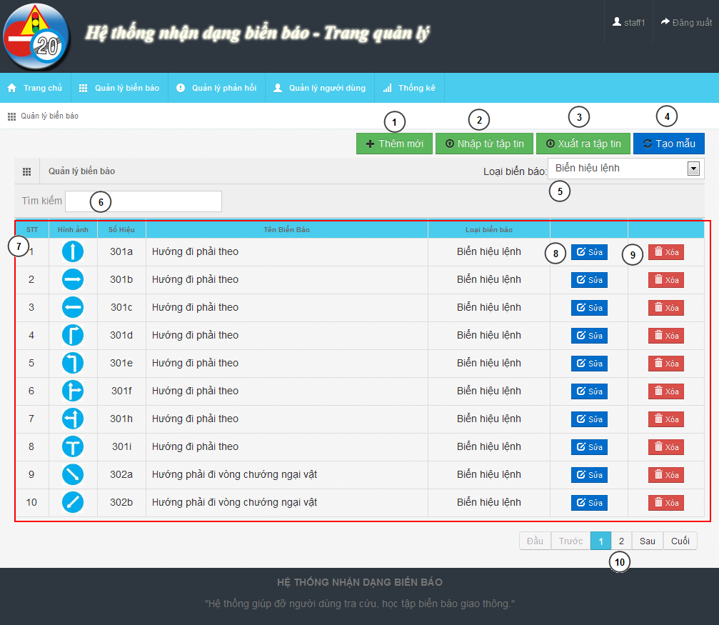

Figure 47: Staff – Traffic Sign Manager Page

**Fields**

|  |  |  |  |  |  |  |  |
| --- | --- | --- | --- | --- | --- | --- | --- |
| **No** | **Field Name** | **Description** | **Read only** | **Mand-atory** | **Control Type** | **Data Type** | **Length** |
| 5 | Traffic sign type | Filter traffic sign by type | N | Y | Dropdown-list | N/A | N/A |
| 6 | Search textbox | Search traffic sign | N | Y | Textbox | String | N/A |
| 7 | Traffic sign list | Traffic sign list | N/A | Y | Table | N/A | N/A |
| 10 | Paging | Paging for traffic sign table | N | Y | N/A | N/A | N/A |

**Button/ Hyperlink**

|  |  |  |  |  |
| --- | --- | --- | --- | --- |
| **No** | **Function** | **Description** | **Validation** | **Outcome** |
| 1 | Add new | Add new traffic sign | No | Traffic sign add new modal |
| 2 | Import data | Import data from file | No | Import data file modal |
| 3 | Export data | Export data to file | No | Zip file |
| 4 | Retrain model | Retrain model from data | No | New model create |
| 8 | Edit traffic sign | Edit traffic sign | No | Edit traffic sign modal |
| 9 | Delete traffic sign | Delete traffic sign | No | Refresh traffic table |

**Table Traffic Sign List includes**

|  |  |  |  |  |  |
| --- | --- | --- | --- | --- | --- |
| **Field Name** | **Description** | **Read only** | **Control Type** | **Data Type** | **Length** |
| No | Order of the row | Y | Label | Integer | N/A |
| Image | Image of traffic sign | Y | Image | Image | N/A |
| Label | Label of traffic sign | Y | Label | String | N/A |
| Name | Name of traffic sign | Y | Label | String | N/A |
| Type | Type of traffic sign | Y | Label | String | N/A |
| Function | Edit traffic sign | N | Button | N/A | N/A |
| Function | Delete traffic sign | N | Button | N/A | N/A |

#### Staff – Report Manager Page

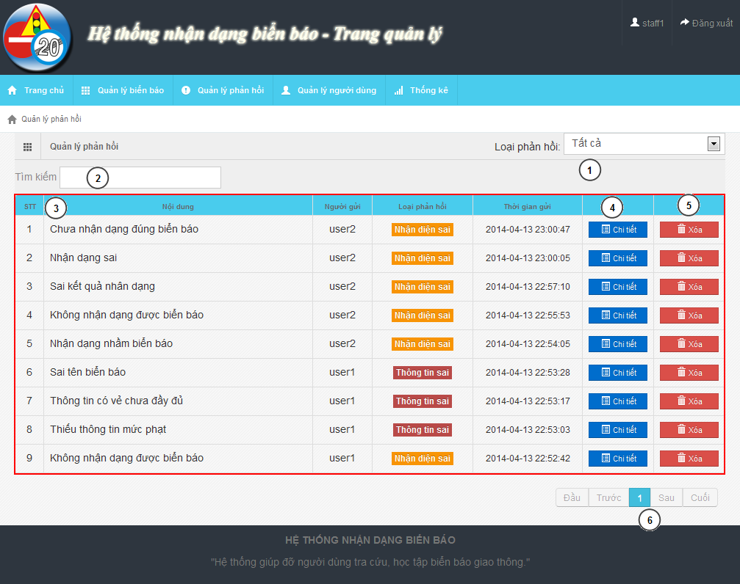

Figure 48: Staff – Report Manager Page

**Fields**

|  |  |  |  |  |  |  |  |
| --- | --- | --- | --- | --- | --- | --- | --- |
| **No** | **Field Name** | **Description** | **Read only** | **Mand-atory** | **Control Type** | **Data Type** | **Length** |
| 1 | Report type | Report type filter | N | Y | Dropdown-list | N/A | N/A |
| 2 | Search field | Search text box for report table | N | Y | Textbox | String | N/A |
| 3 | Report List | List of report | N | Y | Table | N/A | N/A |
| 6 | Paging | Paging for report list | N | Y | N/A | N/A | N/A |

**Button/ Hyperlink**

|  |  |  |  |  |
| --- | --- | --- | --- | --- |
| **No** | **Function** | **Description** | **Validation** | **Outcome** |
| 4 | View detail | View detail of report | No | Show detail report modal |
| 5 | Delete | Delete report | No | Refresh report table |

**Table Report List includes**

|  |  |  |  |  |  |
| --- | --- | --- | --- | --- | --- |
| **Field Name** | **Description** | **Read only** | **Control Type** | **Data Type** | **Length** |
| No | Order of the row | Y | Label | Integer | N/A |
| Content | Content of report | Y | Label | String | N/A |
| Creator | Creator of report | Y | Label | String | N/A |
| Type | Type of report | Y | Label | String | N/A |
| Create date | Create date of report | Y | Label | Date time | N/A |
| Function | View detail button | N | Button | String | N/A |
| Function | Delete button | N | Button | String | N/A |

#### Staff – Account Manager Page

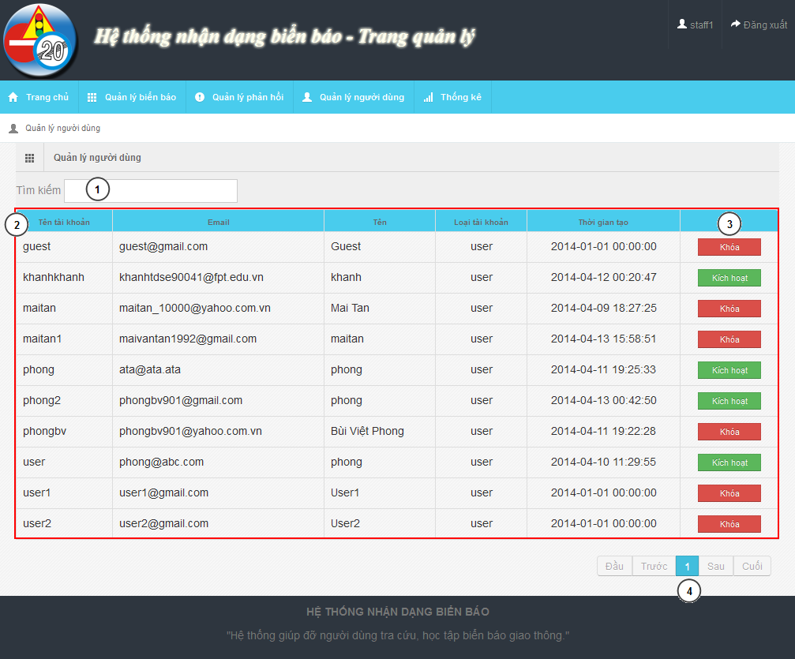

Figure 49: Staff – Account Manager Page

**Fields**

|  |  |  |  |  |  |  |  |
| --- | --- | --- | --- | --- | --- | --- | --- |
| **No** | **Field Name** | **Description** | **Read only** | **Mand-atory** | **Control Type** | **Data Type** | **Length** |
| 1 | Search field | Search textbox for the table | N | Y | Textbox | String | N/A |
| 2 | Account list | List account in system | Y | Y | Table | N/A | N/A |

**Button/ Hyperlink**

|  |  |  |  |  |
| --- | --- | --- | --- | --- |
| **No** | **Function** | **Description** | **Validation** | **Outcome** |
| 3 | Active/Deactivate | Active/deactivate account | No | Change text of button |
| 4 | Paging | Paging area of the student table | No | Change page of the table |

**Table Account List includes**

|  |  |  |  |  |  |
| --- | --- | --- | --- | --- | --- |
| **Field Name** | **Description** | **Read only** | **Control Type** | **Data Type** | **Length** |
| UserID | UserID of account | Y | Label | String | N/A |
| Email | Email of account | Y | Label | String | N/A |
| Name | Name of account | Y | Label | String | N/A |
| Role | Role of account | Y | Label | String | N/A |
| Create date | Create date of account | Y | Label | String | N/A |
| Function | Active/Deactivate account | N | Button | N/A | N/A |

#### Staff – Statistic Page

The same with Admin Statistic Page in 5.2.3

### Mobile Interface Design

#### Login Activity

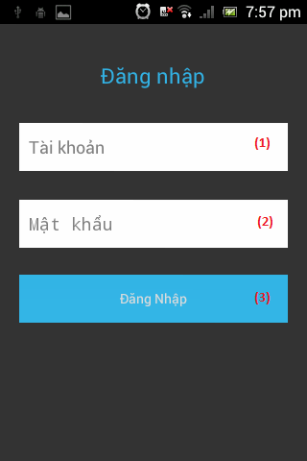

Figure 50: Login Activity

**Fields**

|  |  |  |  |  |  |  |  |
| --- | --- | --- | --- | --- | --- | --- | --- |
| **No** | **Field Name** | **Description** | **Read only** | **Mand-atory** | **Control Type** | **Data Type** | **Length** |
| 1 | Username | Fill user’s username | N | N | Textbox | String | [6, 30] |
| 2 | Password | Fill user’s password | N | N | Textbox | String | [6, 30] |

**Button/ Hyperlink**

|  |  |  |  |  |
| --- | --- | --- | --- | --- |
| **No** | **Function** | **Description** | **Validation** | **Outcome** |
| 3 | Login | Click to login the system | No | Transfer to Main activity |

#### Main Activity

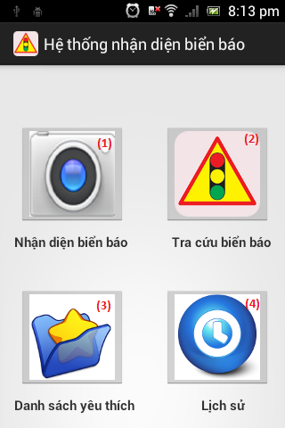

Figure 51: Main Activity

**Button/ Hyperlink**

|  |  |  |  |  |
| --- | --- | --- | --- | --- |
| **No** | **Function** | **Description** | **Validation** | **Outcome** |
| 1 | Search auto | Click transfer to camera activity | No | Transfer to Camera activity |
| 2 | Search manual | Click transfer to category activity | No | Transfer to Category activity |
| 3 | Show favorite list | Click transfer to favorite activity | No | Transfer to Favorite activity |
| 4 | Show history list | Click transfer to history activity | No | Transfer to History activity |

#### Camera Activity

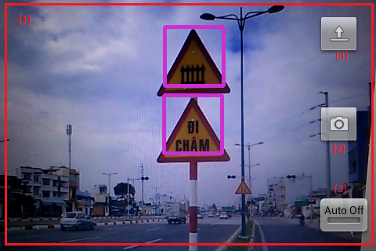

Figure 52: Camera Activity

**Fields**

|  |  |  |  |  |  |  |  |
| --- | --- | --- | --- | --- | --- | --- | --- |
| **No** | **Field Name** | **Description** | **Read only** | **Mandatory** | **Control Type** | **Data Type** | **Length** |
| 1 | Screen view | Show screen of camera on real time | Y | Y | Frame layout | N/A | N/A |

**Button/ Hyperlink**

|  |  |  |  |  |
| --- | --- | --- | --- | --- |
| **No** | **Function** | **Description** | **Validation** | **Outcome** |
| 2 | Capture | Click to capture image | No | Image on real time send to web service and transfer to List result activity |
| 3 | Turn on (off) auto capture mode | Click to turn on or off auto capture mode | No | Turn on (off) auto capture mode |
| 4 | Upload image | Click to select image for upload | No | Image on real time send to web service and transfer to List result activity |

#### List result Activity

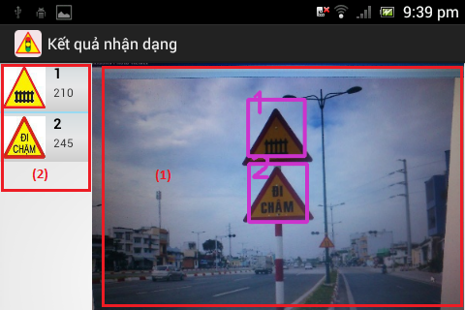

Figure 53: List result Activity

**Fields**

|  |  |  |  |  |  |  |  |
| --- | --- | --- | --- | --- | --- | --- | --- |
| **No** | **Field Name** | **Description** | **Read only** | **Mand-atory** | **Control Type** | **Date Type** | **Length** |
| 1 | Uploaded Image | Display image was uploaded by user. | Y | Y | Image view | N/A | N/A |

**Button/ Hyperlink**

|  |  |  |  |  |
| --- | --- | --- | --- | --- |
| **No** | **Function** | **Description** | **Validation** | **Outcome** |
| 2 | View traffic sign detail | Click one to view traffic sign detail | No | Transfer to Traffic sign detail activity |

**List result includes**

|  |  |  |  |  |  |  |
| --- | --- | --- | --- | --- | --- | --- |
| **Field Name** | **Description** | **Read only** | **Control Type** | **Color** | **Data Type** | **Length** |
| Position | Display position of result match with image. | Y | Textview | Black | String | N/A |
| Traffic ID | Display traffic’s ID number | Y | Textview | Black | String | N/A |
| Traffic image | Display traffic’s image | Y | Imageview | N/A | N/A | N/A |

#### Category Activity

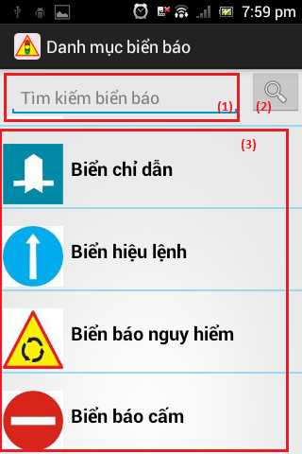

Figure 54: Category Activity

**Fields**

|  |  |  |  |  |  |  |  |
| --- | --- | --- | --- | --- | --- | --- | --- |
| **No** | **Field Name** | **Description** | **Read only** | **Mandatory** | **Control Type** | **Date Type** | **Length** |
| 1 | Search key | Key for search traffic sign by traffic’s name | N | N | Edit text | String | N/A |

**Button/ Hyperlink**

|  |  |  |  |  |
| --- | --- | --- | --- | --- |
| **No** | **Function** | **Description** | **Validation** | **Outcome** |
| 2 | Search traffic sign by name | Click to search traffic sign by traffic’s name | No | Search traffic sign then transfer to List traffic sign activity |
| 3 | Search traffic sign by category | Click to search traffic sign by category which was selected | No | Search traffic sign then transfer to List traffic sign activity |

**Category list includes**

|  |  |  |  |  |  |
| --- | --- | --- | --- | --- | --- |
| **Field Name** | **Description** | **Read only** | **Control Type** | **Data Type** | **Length** |
| Category image | Display category’s image | Y | Imageview | N/A | N/A |
| Category name | Display category’s name | Y | Textview | String | N/A |

#### List traffic sign Activity

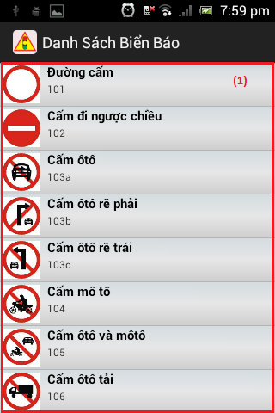

Figure 55: Category Activity

**Button/ Hyperlink**

|  |  |  |  |  |
| --- | --- | --- | --- | --- |
| **No** | **Function** | **Description** | **Validation** | **Outcome** |
| 1 | View traffic sign detail | Click view traffic sign detail | No | Transfer to Traffic sign detail activity |

**Traffic sign list includes**

|  |  |  |  |  |  |
| --- | --- | --- | --- | --- | --- |
| **Field Name** | **Description** | **Read only** | **Control Type** | **Data Type** | **Length** |
| Traffic sign image | Display traffic sign’s image | Y | Imageview | N/A | N/A |
| Traffic sign name | Display traffic sign’s name | Y | Textview | String | N/A |
| Traffic sign ID | Display traffic sign’s ID number | Y | Textview | String | N/A |

#### Traffic sign detail Activity

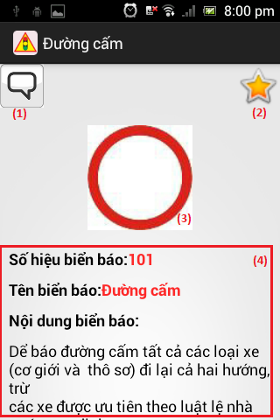

Figure 56: Traffic sign detail Activity

**Fields**

|  |  |  |  |  |  |  |  |
| --- | --- | --- | --- | --- | --- | --- | --- |
| **No** | **Field Name** | **Description** | **Read only** | **Mandatory** | **Control Type** | **Date Type** | **Length** |
| 3 | Traffic sign image | Display traffic sign’s image | Y | Y | Imageview | N/A | N/A |
| 4 | Traffic sign information | Display traffic sign’s detail information | Y | Y | Textview | String | N/A |

**Button/ Hyperlink**

|  |  |  |  |  |
| --- | --- | --- | --- | --- |
| **No** | **Function** | **Description** | **Validation** | **Outcome** |
| 1 | Send report | Click to transfer to report activity | No | Transfer to Report activity |
| 2 | Add/Remove favorite | Click to add or remove traffic sign to favorite list. | No | Send request to service for add/delete traffic sign to favorite list. |

#### Favorite Activity

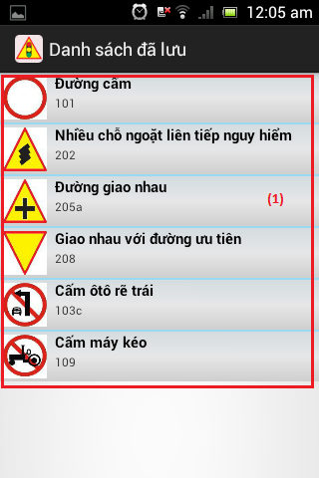

Figure 57: Favorite Activity

**Button/ Hyperlink**

|  |  |  |  |  |
| --- | --- | --- | --- | --- |
| **No** | **Function** | **Description** | **Validation** | **Outcome** |
| 1 | View traffic sign detail | Click to transfer to traffic sign detail activity | No | Transfer to Traffic sign detail activity |

**Favorite list includes**

|  |  |  |  |  |  |
| --- | --- | --- | --- | --- | --- |
| **Field Name** | **Description** | **Read only** | **Control Type** | **Data Type** | **Length** |
| Traffic sign image | Display traffic sign’s image | Y | Imageview | N/A | N/A |
| Traffic sign name | Display traffic sign’s name | Y | Textview | String | N/A |
| Traffic sign ID | Display traffic sign’s ID number | Y | Textview | String | N/A |

#### History Activity

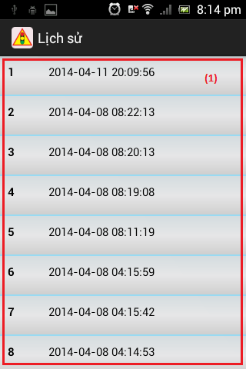

Figure 58: Favorite Activity

**Button/ Hyperlink**

|  |  |  |  |  |
| --- | --- | --- | --- | --- |
| **No** | **Function** | **Description** | **Validation** | **Outcome** |
| 1 | View history detail | Click to transfer to list result activity | No | Transfer to List result activity |

**History list includes**

|  |  |  |  |  |  |
| --- | --- | --- | --- | --- | --- |
| **Field Name** | **Description** | **Read only** | **Control Type** | **Data Type** | **Length** |
| Position | Display order number in the list | Y | Textview | String | N/A |
| Create date | Display history’s create date | Y | Textview | String | N/A |

## Database Design

### Entity Relationship Diagram

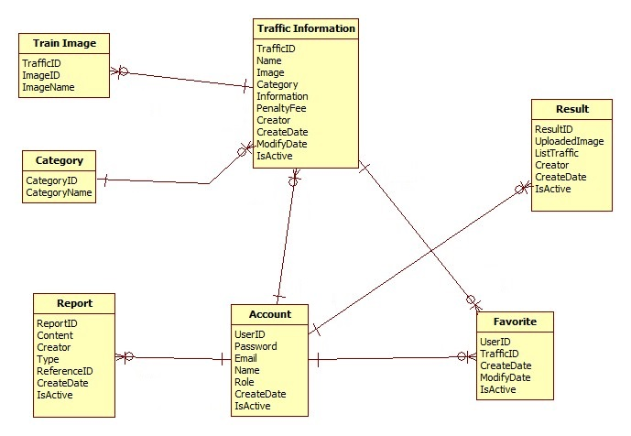

Figure 59: Entity Relationship Diagram

### Data Dictionary

|  |  |
| --- | --- |
| **Data dictionary: describe content of all entities** | |
| Name | Description |
| Traffic Information | Describe information about traffic sign |
| Train Image | Describe information about image use to train/recognize a traffic sign |
| Category | Describe all type of traffic sign |
| Report | Describe information about report of user. Contain wrong information report and wrong recognition report |
| Account | Describe all information about user in the system |
| Result | Describe information about search auto result |
| Favorite | Describe information about favorite traffic sign of user |

Table 40: Data Dictionary

|  |  |  |  |  |
| --- | --- | --- | --- | --- |
| **Name** | **Attributes** | **Description** | **Domain** | **Nulls** |
| trainimage | imageID {PK}  trafficID {FK}  imageName | ImageID of train image  Traffic ID of train image  Image name of train image | 255 nvar  11 nvar  255 nvar | No  No  No |
| category | categoryID {PK}  categoryName | Uniquely identifier  Name of category | Int  30 nvar | No  No |
| favorite | creator {PK, FK}  trafficID {PK, FK}  createDate  modifyDate  isActive | Creator of favorite  TrafficiD of favorite  Create date  Modify date  Status | 11 nvar  11 nvar  Date  Date  Bit | No  No  Yes  Yes  Yes |
| trafficinformation | trafficID {PK}  name  image  categoryID {FK}  information  penaltyfee  creator {FK}  createDate  modifyDate  isActive | Uniquely identifies, auto increment  Name of traffic sign  Image of traffic sign  Category ID of traffic sign  Information of traffic sign  Penalty fee of traffic sign  Creator  Create date  Modify date  Status | 11 nvar  255 nvar  255 nvar  Int  4000nvar  255 nvar  30 nvar  Date  Date  Bit | No  No  No  No  Yes  Yes  No  Yes  Yes  Yes |
| account | userID {PK}  password  email  name  role  createDate  isActive | Uniquely identifies, ID of user  Password of user in MD5 form  Email of user  Name of user  Role of user  Create date  Status | 30 nvar  255 nvar  30 nvar  30 nvar  10 nvar  Date  Bit | No  No  No  Yes  No  No  No |
| result | resuitlID {PK}  uploadedImage  listTraffic  creator  createDate  isActive | Uniquely identifies, auto increment  Image link  List contain trafficID and location in image  Create of result  Create date  Status | Int  255 nvar  4000nvar  30 nvar  Date  Bit | No  No  Yes  Yes  Yes  Yes |
| report | reportID {PK}  referenceID  content  creator {FK}  type  createDate  isActive | Uniquely identifies, auto increment  ReferenceID depend on type report  Report content  Creator  Type of report  Create date  Status | Int  11 nvar  4000nvar  30 nvar  Int  Date  Bit | No  No  Yes  No  No  Yes  Yes |

Table 41: Attribute Data Dictionary

## Algorithms

### Traffic sign detection

#### Definition

Traffic Sign Detection is a technology that determines the locations and sizes of traffic signs in images.

#### Different method for traffic sign detection

There are many ways to detect traffic sign in an image:

* Color-based detect method
* Shape-based detect method
* Machine learning method:

+ Artificial Neural Network

+ Word bag

+ Classifier cascade

+…

#### The method we chose

We chose the Viola-Jones method (a classifier cascade method). Reason:

* Already implemented in OpenCV (that support many platforms: Linux, Windows, Android…)
* Easy to extend base on train cascade file.
* Easy to use and handle in code.
* High accurate rate (base on testing with another method)

**Method Introduction**

The Viola-Jones (V-J) object detection framework is the first object detection framework to provide competitive object rates in real-time proposed. It can be trained to detect a variety of object classes. In OpenCV, it’s implemented as cvHaarDetectObjects() and the new method for multithread is cascadeClassifier()

Reference: <http://en.wikipedia.org/wiki/Viola%E2%80%93Jones_object_detection_framework>

Key ideas of Viola-Jones:

* Integral images for fast feature evaluation
* Boosting for feature selection
* Attentional cascade for fast rejection of non-object windows

Viola-Jones Technique:

* Feature extraction and feature evaluation
* Classifier training a feature selection using a method called AdaBoost.
* A degenerate decision tree of classifiers is formed.

**Feature extraction and feature evaluation:**

Feature extraction:

* Rectangle feature with four basic types. Value = sum( pixels in black area) – sum(pixels in white area)
* Each feature is related to a special location in the sub-window
* Each feature may have any size



Figure 60: Four basic types

**Feature evaluation**: using Integral Image for rapid computation of rectangular features.

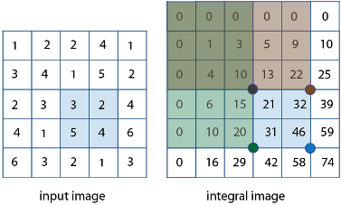

Figure 61: Integral Image

**Feature selection:** Using AdaBoost stands for “Adaptive” boost

* Constructs a “strong” classifier as a linear combination of weighted simple “weak” classifiers
* Features as weak classifiers: each single feature may be regarded as a simple weak classifier.
* An iterative algorithm: AdaBoost performs a series of trials, each time selecting a new weak classifier.
* Weights are being applied over the set of the example images: during each iteration, each example/image receives a weight determining it importance.

**Decision tree:** Attentional Cascade

* The reason the technique is fast.
* Quick rejection of sub windows.

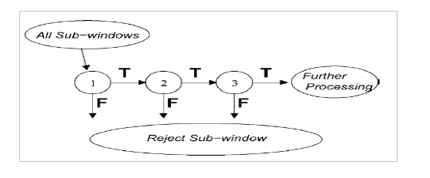

Figure 62: Attentional Cascade

**All Viola-Jones flow chart:**

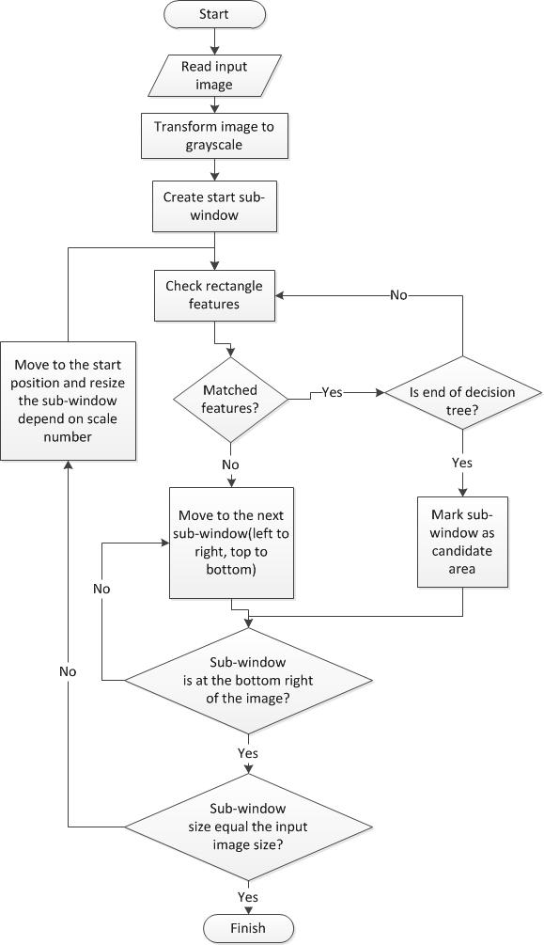

Figure 63: Viola-Jones flow chart

#### Train data to use Viola-Jones algorithm

To apply the algorithm in project, we device traffic sign into 2 main class: one for triangle traffic sign (warning traffic sign), one for circle traffic sign (prohibitory, mandatory traffic sign).

The image use to train each class contain 2 types:

Positive image: contain only traffic sign image clipped.

Negative image: contain what every image not have traffic sign, such as the image of street, market, tree…

Here is the example for the positive training sample:

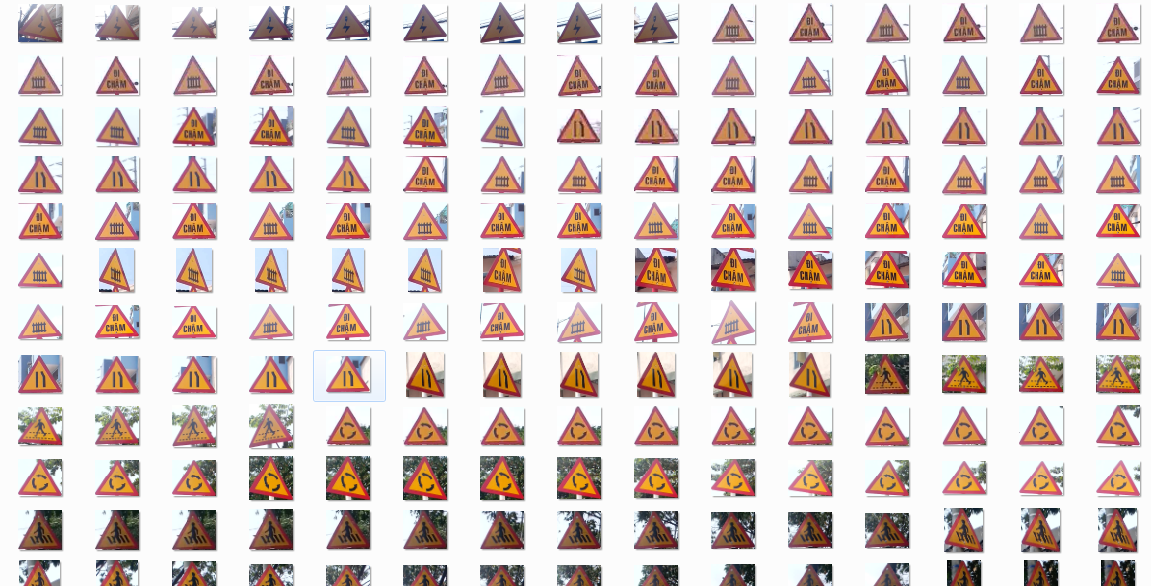

Figure 64: Triangle Traffic Sign Train Sample Image

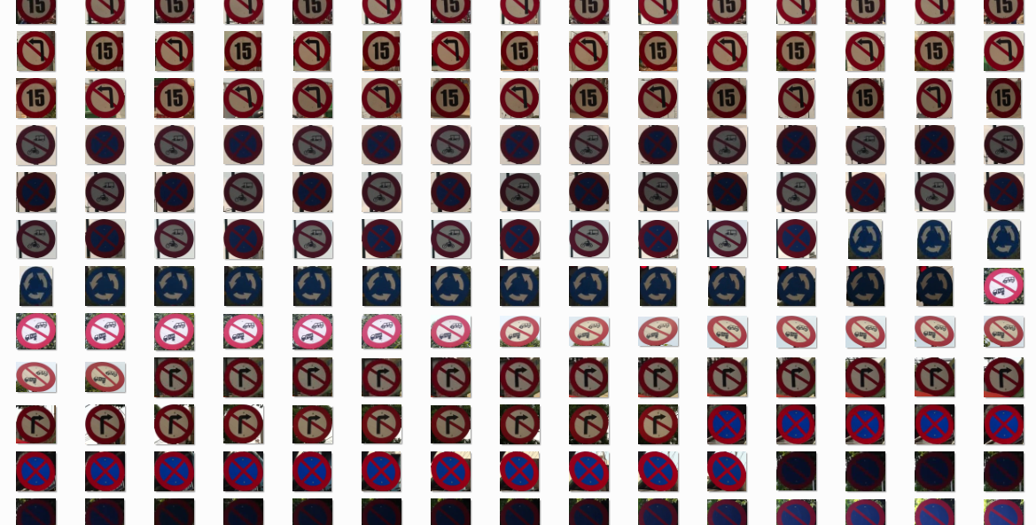

Figure 65: Circle Traffic Sign Train Sample Image

And negative sample:



Figure 66: Negative Train Sample Image

We trained the image many time and get the best detection rate with about 700 positive images and 1500 negative images to each class (see the performance measures about the detect rate chart). The time need to train each class is about 3 days with Core i3 M350 2.27 GHz, 2GB Ram available. The result of each train is a XML cascade file contain features to detect traffic sign.

### Traffic sign recognition

#### Definition

* Traffic sign recognition is identify the name of traffic sign from detected area in an image.

#### Method for traffic sign recognition

**There are many way to recognize traffic sign from detect area in an image:**

* **Artificial neural network**
* **Nearest-Neighbor Classifiers**
* **Decision Trees**
* **…**

References: <http://sundog.stsci.edu/rick/SCMA/node2.html>

#### The Method we choose

**We chose SVM multi-class method, reason:**

* Implemented in many library
* Easy to integrate in project

**Method Introduction**

**Support vector machine (SVMs) are supervised learning models with associated learning algorithms what analyze data and recognize pattern used for classification and regression analysis.**

**Basic SVM only support to classify 2 classes.**

**Multiclass SVM: assign labels to instances by using support vector machines, where the labels are drawn from a finite set of several elements.**

**This approach is extend of basic SVM (binary classification):**

**One-versus-all: Using binary classifiers with between one of the labels and the rest. The result calculate by winner-takes-all, in which the classifier with the highest output function assigns the class.**

**One-versus-one: between every pair of classes. The result calculate by max-wins voting strategy, in which every classifier assigns the instance to one of the two classes, then the vote for assigned class is increased by one vote, and finally the class with the most votes determines the instance classification.**

**In this project we use SVM multi-class with One-versus-all method.**

Reference:

<http://en.wikipedia.org/wiki/Support_Vector_Machine>

<http://www.cs.cornell.edu/people/tj/svm_light/svm_multiclass.html>

**Algorithm description:**

* Extract features of image
* Compare these features with the features of the model and get the best matched rate model (SVM multi-class One-versus-all)

**Extract feature of image**: Histogram of oriented gradients (HOG) features. The technique counts occurrences of gradient orientation in localized portions of an image.

Reference: <http://en.wikipedia.org/wiki/Histogram_of_oriented_gradients>

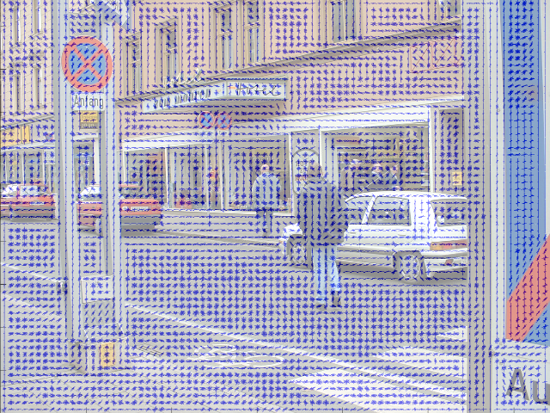

Figure 67: HOI features

**SVM classifier:** Base on features SVM classifier can calculate the rate that match with model and give the candidate model for object

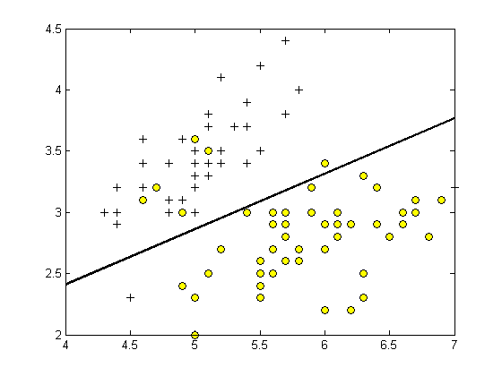

Figure 68: SVM classifier

**Classifier flow chart**

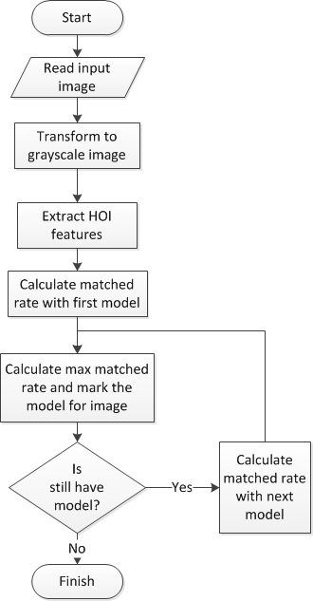

Figure 69: Classifier flow chart